Biology 100
Student’s Name
Institutional Affiliation

Biology 100
1.
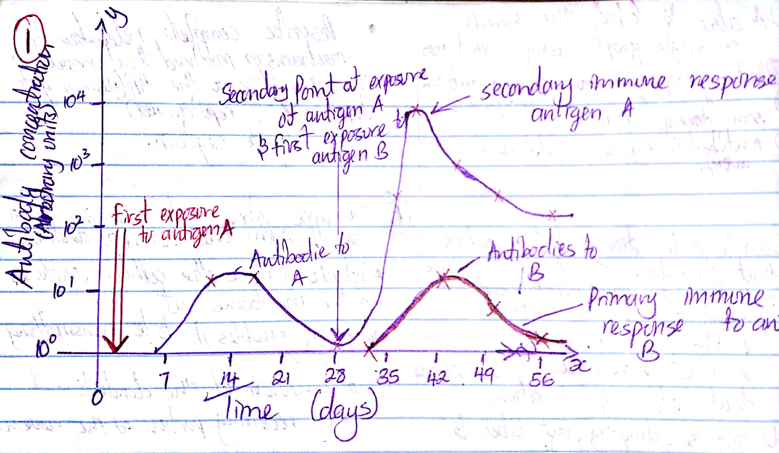

The primary response for both antigens has almost the same antibody concentration response in a period of 21 days while the secondary response to the antigen A causes a spike in antibody concentration

2.
T cells are essential in the B cells activation once combined with antigens outside of the follicles. There is a high plausibility that the B cells’ future is affected by the hyper mutation. This may result in amino acid replacements in the immunoglobulin V regions. The T cells are important because they promote BCR cross-linking. If BCR cross-linking does not occur, B cells cannot present peptide antigens to T cells hence leading to apoptosis. However, if the T Cells promote the BCR cross linking successfully then the B cells proliferate and mature leading to plasma all cells and memory B cells.
Many of the mutations are negative or neutral therefore the germinal center is a site for massive B cells death or proliferation. Plasma cells go to the bone marrow where most live for very long periods. Plasma cells acquire signals from the stromal cells inside bone marrow that are important in their survival for procession of long lasting high affinity antibodies. Signals from follicular dendritic cells are important in triggering B cells to become memory cells. However, another possibility is that antigen affinity takes over B cell differentiation with high affinity cells perhaps being preferentially stimulated to grow into memory cells.
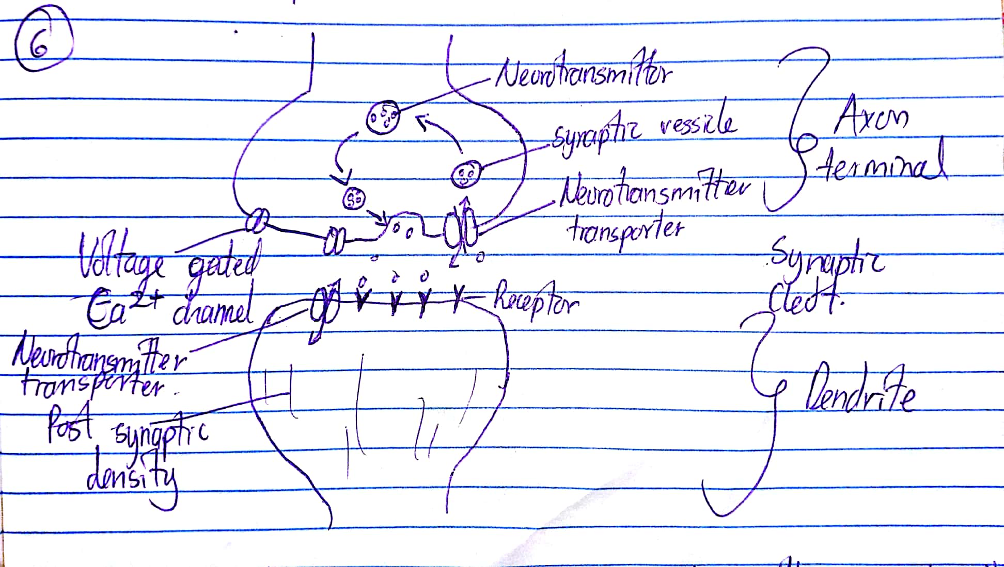
3.
Cytokines such as interleukin 2acts as differentiation factors during clonal expansion of CD8+ T cells to cytotoxic T cells. Engagement of CD8+ T cells receptors with peptide MHC complexes of antigens causes’ naïve CD8+ T cells to proliferate and differentiate into cytotoxic T lymphocytes. Exposure of naïve CD8+ T cells to antigens of a pathogen causes them to proliferate to cytotoxic effector cells where some remain after infection leaves as memory CD8+ T cells. Furthermore, interaction of naïve CD8+ T cells with dendritic cells also gives rise to long lasting memory T cells.
T helper cells are important in the reorganization of gene segments so as a specific antigen binding molecule is expressed i.e. T cell receptor (TCR).
Cytotoxic T lymphocytes have T cell receptors that allow monitoring of the cells of the body ready to destroy any cell posing a threat to the living organism. Lent a hand by cytotoxicity that is exerted directly through perforin or fas pathway and or indirectly having cytokines released.

4.
An antigen is any molecule that can bind specifically to an antibody. Those that can induce antibody production are called immunogens. An antibody is a protein that binds specifically to an antigen. Collectively, they are known as immunoglobulins. They are produced by the plasma cells in response to infection or immunization binding and neutralizing to pathogen in preparation for phagocytosis. Antibiotics are antimicrobial drugs used in the treatment and prevention of bacterial infections. They either kill or have an inhibitory effect on bacterial growth.
Antigens, antibodies, and antibiotics differ in their functionality. For instance, antigens are harmful microorganisms or substances that can cause degradation of one’s health and may trigger immune response. Antibodies are unique proteins that human cells produce in order to fight against disease causing bacteria while the antibiotics are chemicals got from microorganisms with capability of inhibiting and preventing growth of disease causing bacteria.
5.
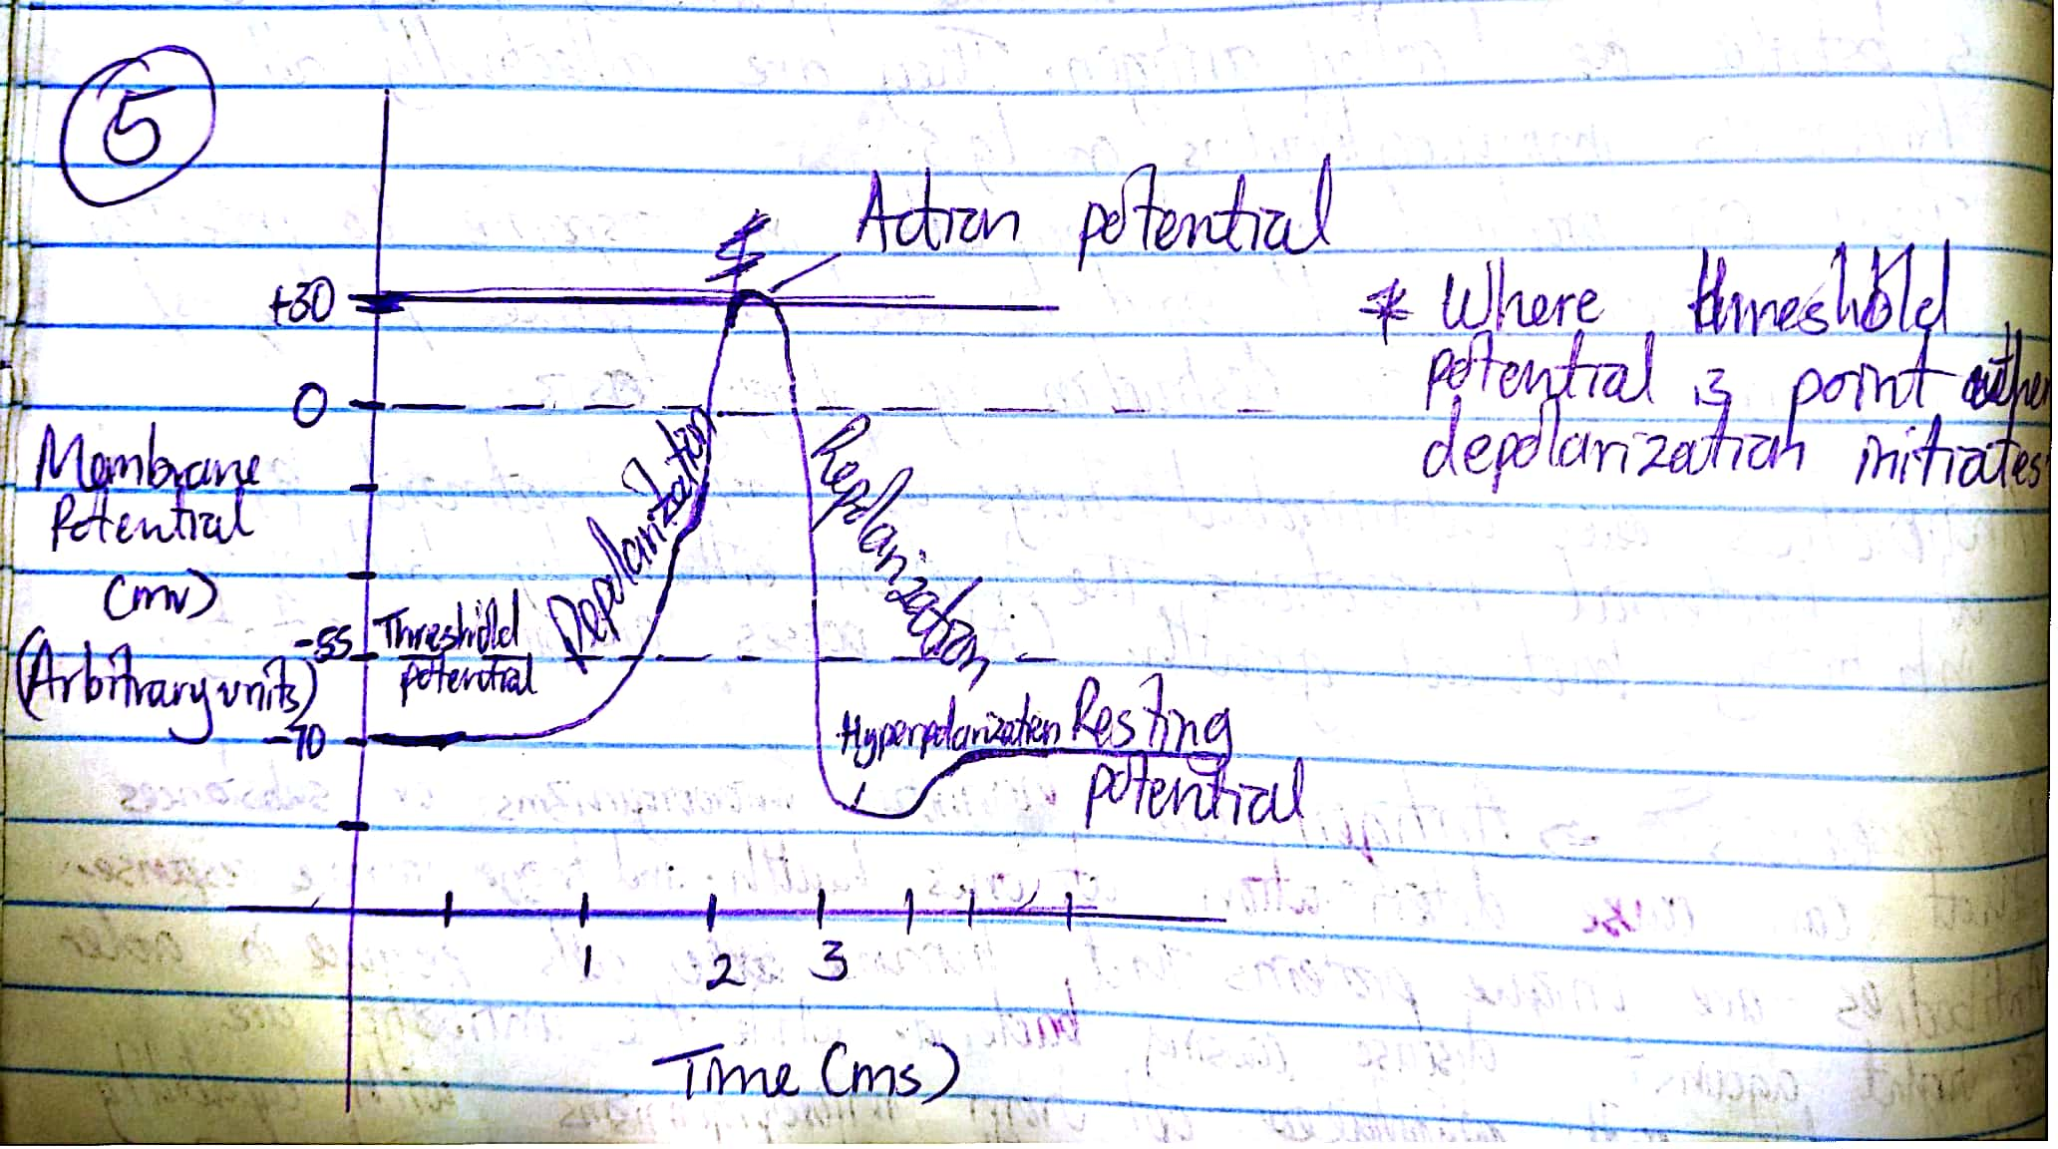
Starting from resting potential; Sodium ions (Na+) gates open. Sodium ions flow into the axon through a pump mechanism and lead to the inversion of polarity (positive on the inside and negative on the outside). This state is known as depolarization. With assistance from the pump mechanism, the sodium ion gates close and the potassium ion (K+) gates open. K+ flows out causing repolarization. This process is carried out in a continuous wave like flow.

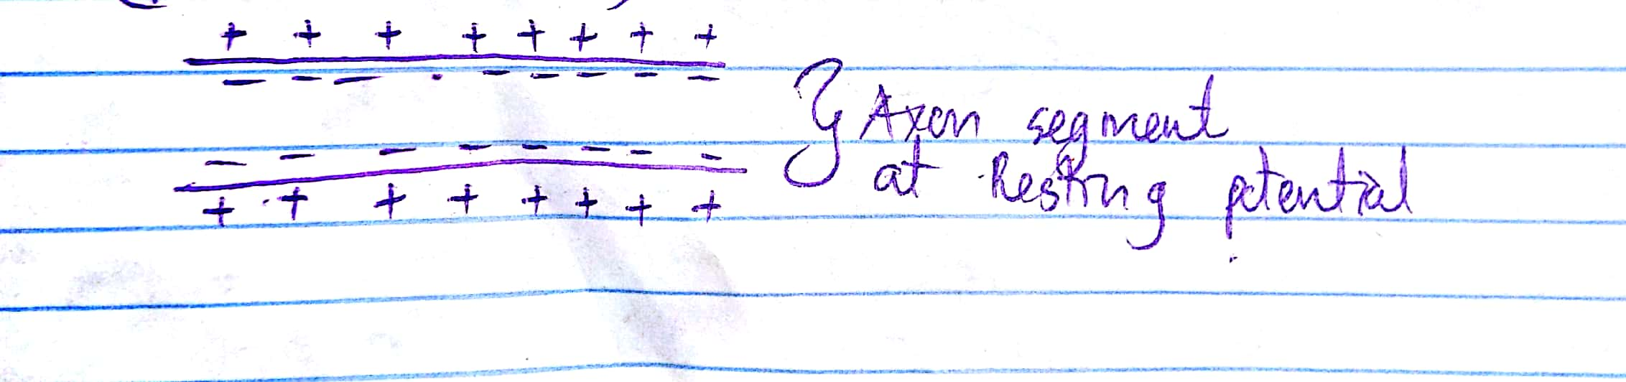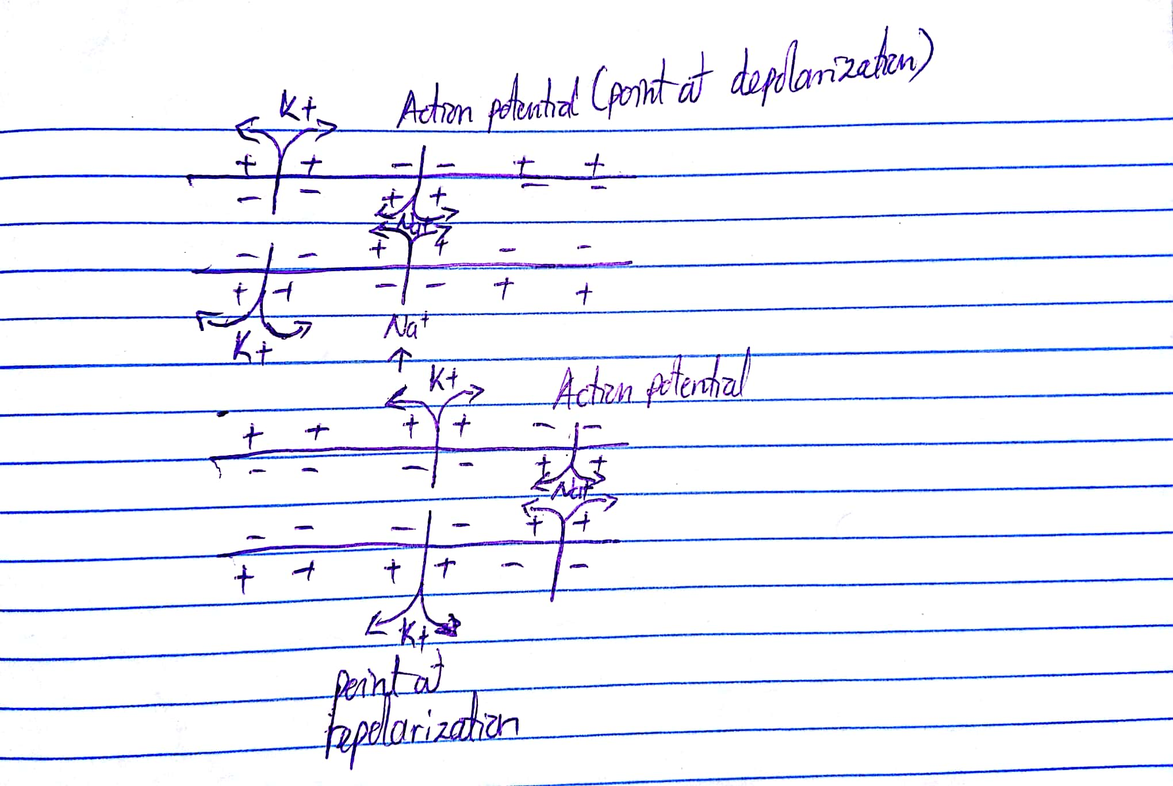

6.
The axon terminal has the synaptic vesicles with a neurotransmitter (acetylcholine) that enable transfer of information while the dendrite possesses neurotransmitter receptors on its surface.
7.
The postsynaptic neuron will fire since the drug blocked the release of the inhibitory neurotransmitter will be released onto the postsynaptic neuron causing it to fire.

